USE OF TABLE RETRIEVAL SETUP IN CSPRO ON POPHOUS DATA

Pophous National Statistical Office
Capital, Pophous

INTRODUCTION

Table Retrieval Setup is a CSPro tool that allows users to create and modify a set of tables and other documents organized by geographic area, subject and title for use by CSPro Table Retrieval tool. The Table Retrieval tool allows users to select by geographic area and title one or more tables or other documents and retrieve the selected tables or documents. This tool is useful to disseminate in electronic form documents and tables from a survey or census.

The tables are developed using CSPro’s Tabulation Application, which requires geographic hierarchy provided from an Area names File. The Area Names File includes the Major and Minor Civil Divisions, and other, lower level geography.

CREATING A TABLE RETRIVAL SETUP (TRS)

In order to create TRS the user must first make the appropriate tables. The new table is created by clicking the Microsoft symbol for a new file (or using the command Ctrl + N). The user then must select ‘Tabulation Application’ –the key pad- from the choices shown. Keying and edit applications can also be made but for the purpose of TRS, only the Tabulation Application is needed.

Figure 1. Creating a Tabulation Application
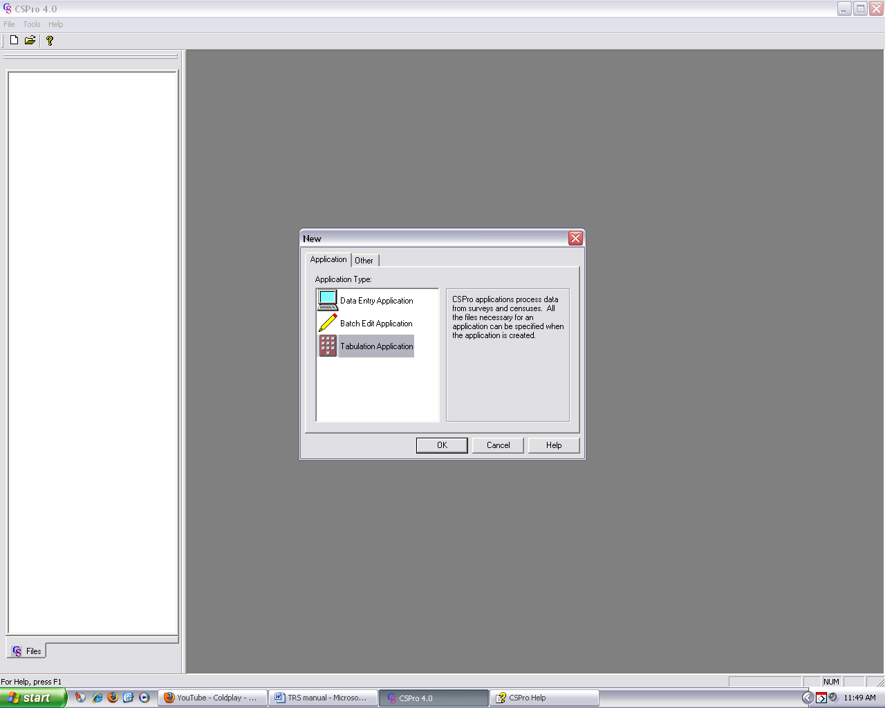

The next step is to name the newly created tabulation file. The user is free to determine a naming convention which will aid in organizing the sets of tables for current and future use.

Figure 2. Determine a name for the application

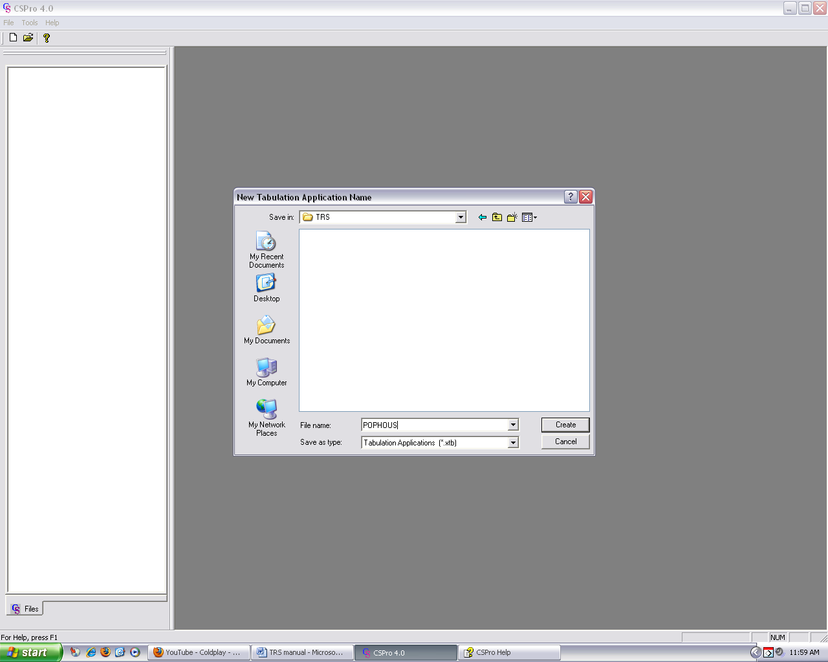

After the table is defined, CSPro will ask for the name of the dictionary to be used to generate the table. Often, the name of the dictionary is the same as the table set, and so the user can go right on. But, if the dictionary name differs from the name of the set of tables, then the dictionary must be selected. As show in Figure 3, external dictionaries can also be called which would be the case for lookup files for industry and occupation or places of births or previous residences. The area Names File is a kind of look up file but it is called separately as noted below.

Figure 3. Selecting a Dictionary for the Application
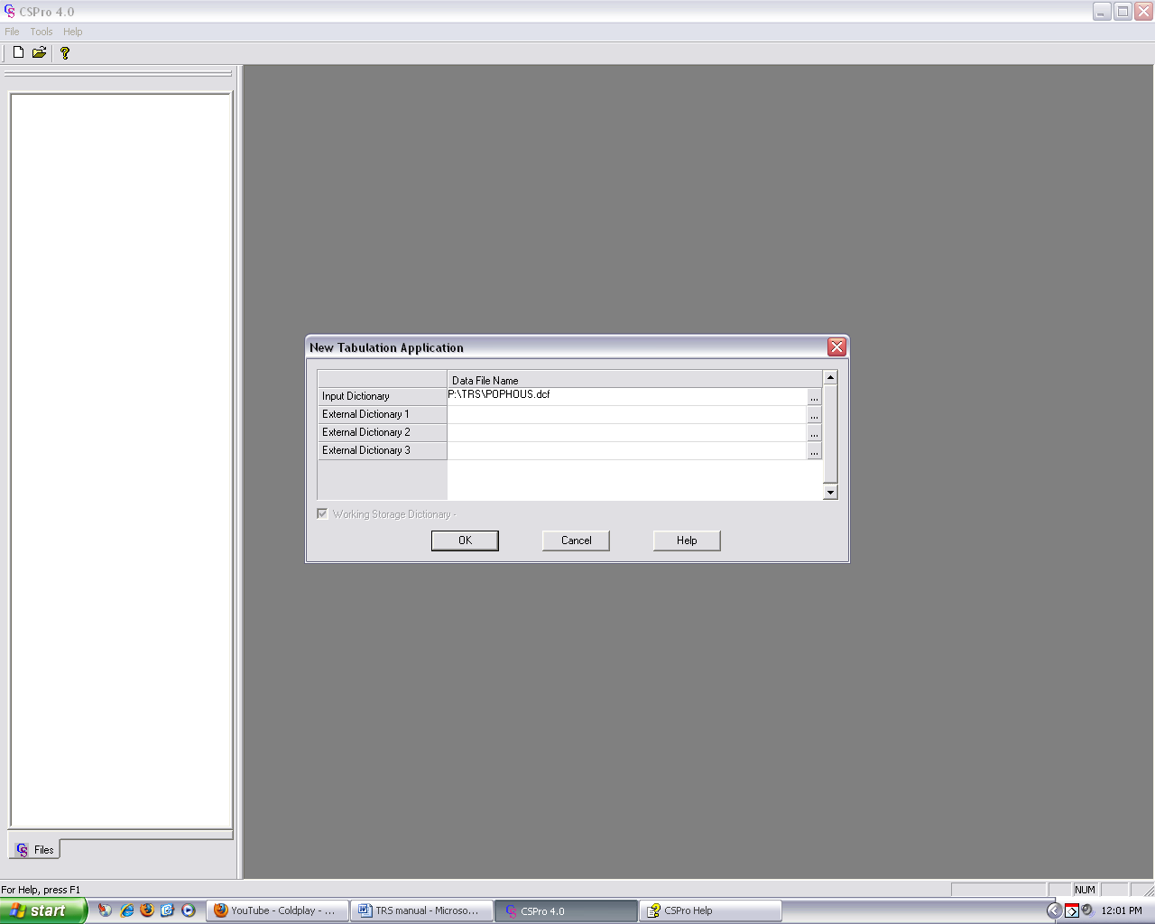

In the tables made for TRS application, the geographic levels are not hard code. Instead, the geography comes from another file, called the Area Names File. But, as shown in Figure 4, the initial table is the same – in this case we are going to get a table that crossed Province and District by Marital Status.

In order to obtain the geographic levels for the table, the user clicks the ‘Area’ icon – the image with three yellow boxes:

The figure allows the selection of the geography to be shown in the table. Figure 4 below also shows selection of Province and District for POPHOUS.

Figure 4. Making a table for TRS and Selecting Geographic hierarchy
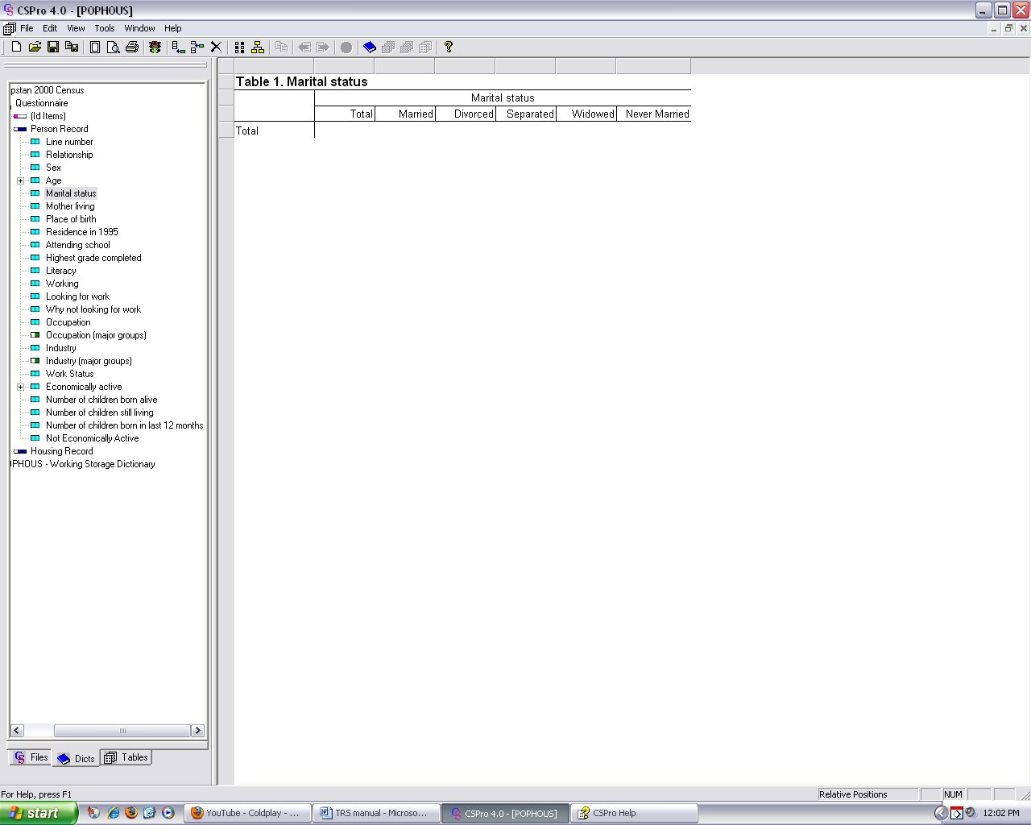
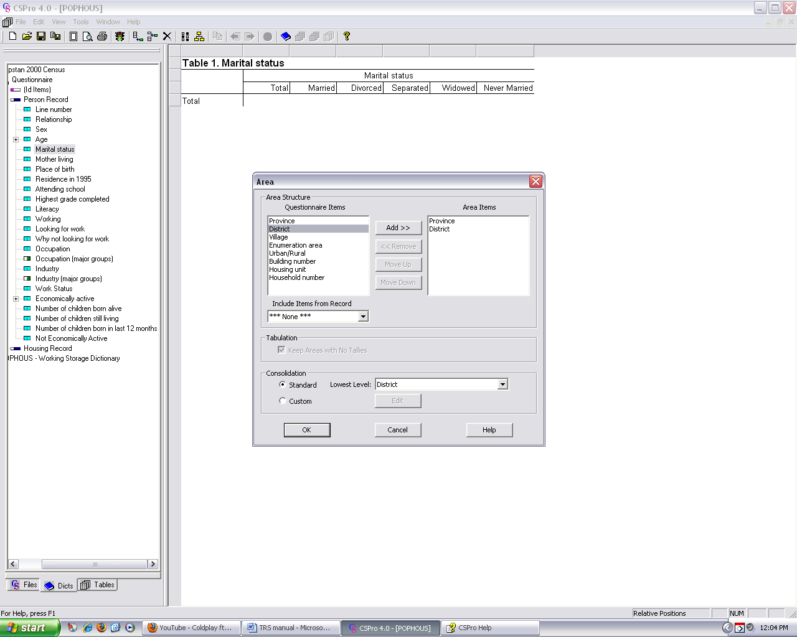
After the levels of geography are shown, the user must declare where the area names are located – that is, the name of the area names file. So, the table requires the name of data set, the name of the table to be produced, and the area names file as shown in Figure 5.

Figure 5. Adding the Area Names file

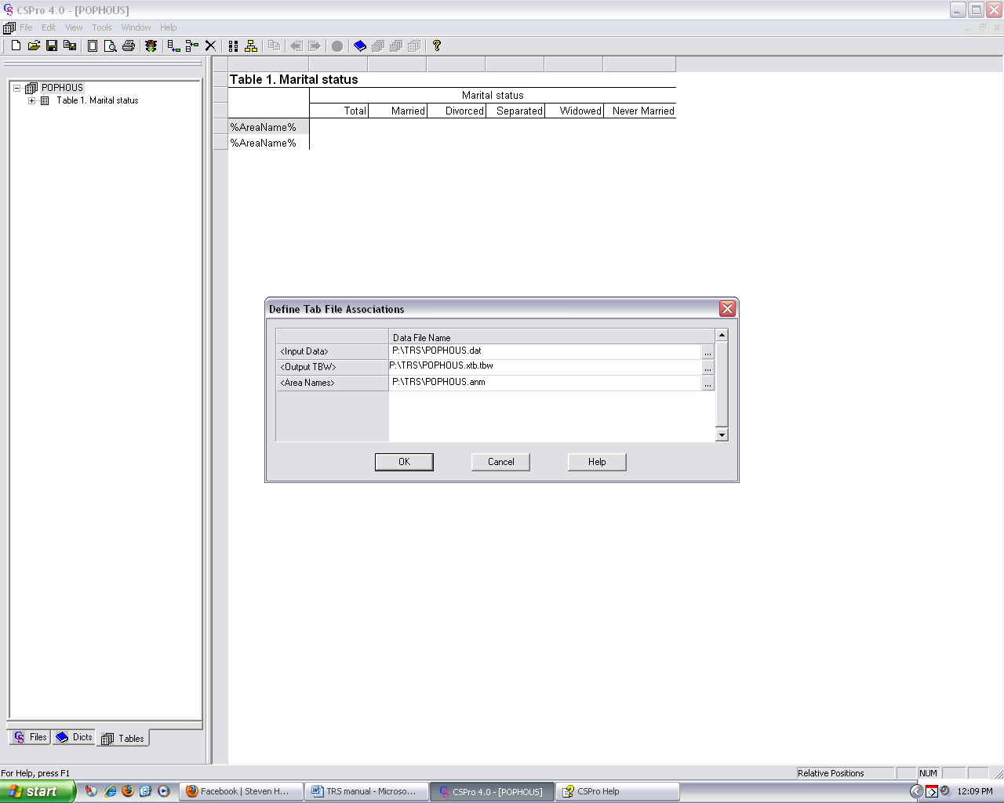

As noted above, the tables prepared for TRS must be made in conjunction with an Area Names file. The Area Names file provides the geographic information needed for tables presented in the geographic hierarchy whether or not a map is made subsequently. An example of what the Area Names file looks like appears below in Figure 6. Note that CSPro provides assistance in its help menus to develop Area Names file. The file must be an ASCII text file and must have the geography presented in hierarchical form only – messages are printed when geography is out of order. Also, if codes are present, but names do not accompany codes, the numbers will be printed in the absence of the names.

Figure 6. Piece of Area Names File

[Area Names]
Version=CSPro 4.0

[Levels]
Name=Province
Name=District

[Areas]
X X = Pophous
1 X = Artesia
1 1 = Dongo
1 2 = Idfu
1 3 = Jummu
1 4 = Kars
1 5 = Kuma
1 6 = Lanti

Below is Figure showing how a table looks after it is made. Note that the geography follows the hierarchy just as in the Area Names File. The user must save the table (or set of tables) once it is made. This can be done by clicking the Microsoft symbol for ‘save’ or using the command ‘Ctrl + S.’

Figure 7. Sample of Table for Marital Status for geographic Levels.

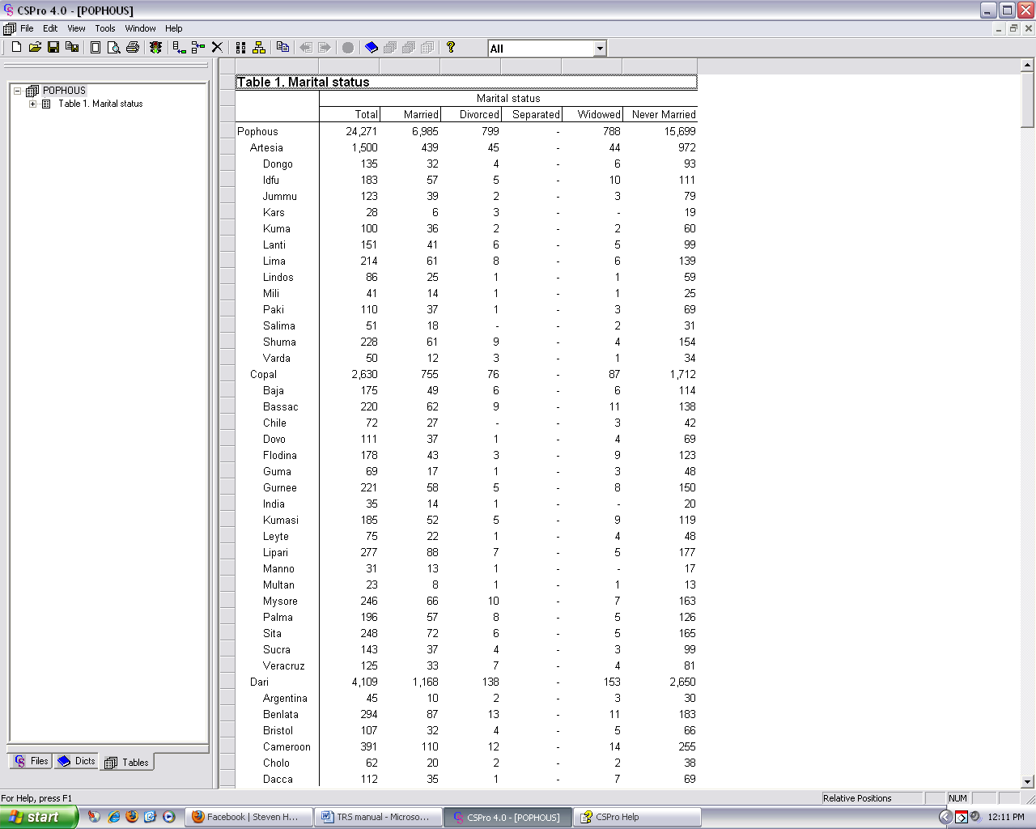

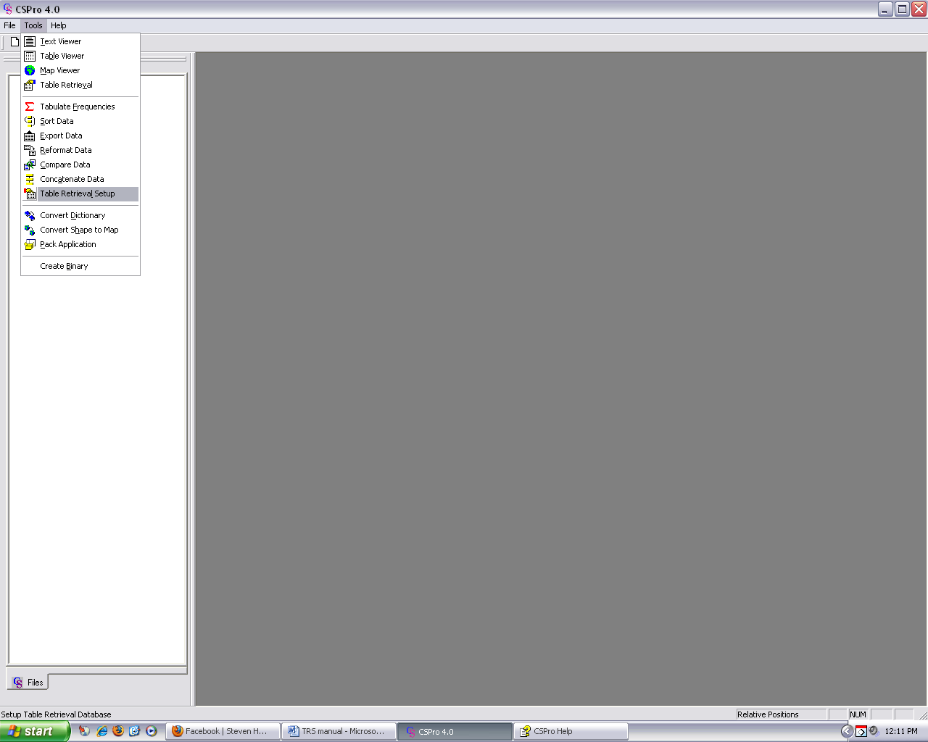
Table Retrieval Setup will allow the user to define how they want the tables to be retrieved. Users will be able to choose and include desired tables, change table names as well as cluster the tables with respect to themes or subjects i.e. economics, fertility etc. To Create a TRS, the user starts by selecting Table Retrieval Setup from CSPro Tools menu as shown below in Figure 8.

Figure 8. Selecting the Table retrieval Setup

The user then has the option of creating a new TRS or opening an existing one from a dialog box that appears after selecting Table Retrieval Setup from the Tools menu. Select ‘Create new TRS application’ and click OK as shown in Figure 9 below.

Figure 9. Creating a new TRS application
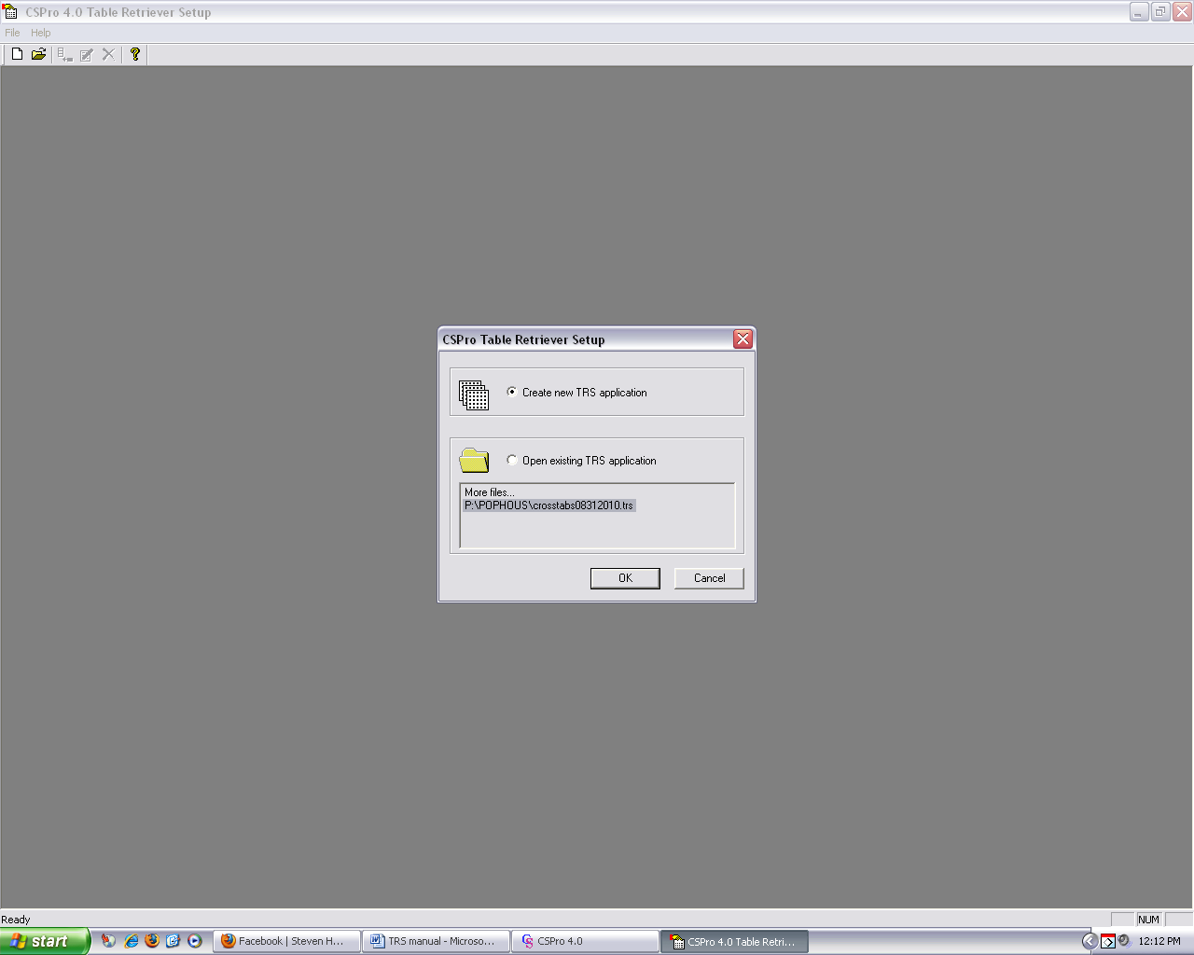

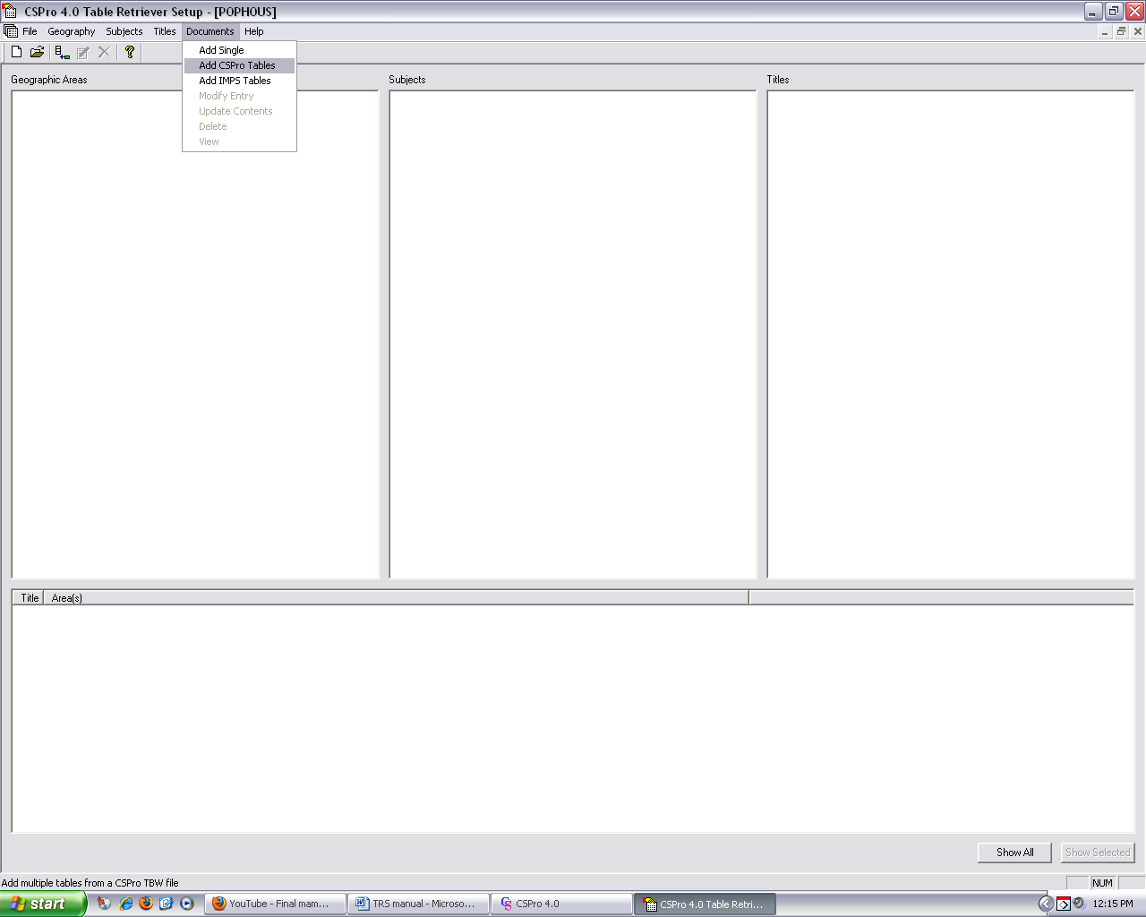

Just as in creating a table, the user then names the TRS application using a naming convention of their choosing. In Figure 10. below, the file is named POPHOUS.

Figure 10. Naming the TRS file
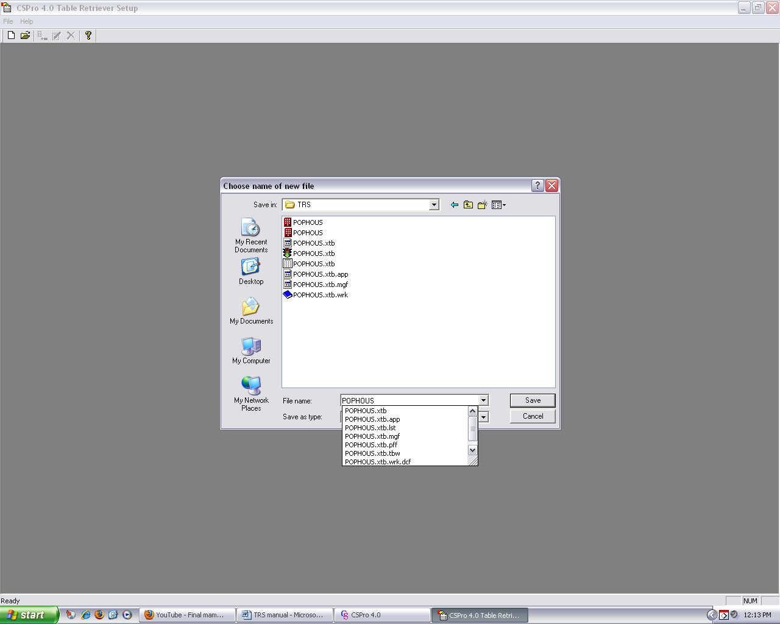

Next, the user adds the tables that were made earlier. This can be done by selecting Add CSPro Tables from the TRS’s Documents menu. The user will then be prompted to select the table they wish to add into the TRS. Note that all the CSPro table files will have a ‘tbw’ extension. Figure 11 below shows the CSPro table POPHOUS being selected for addition into the TRS. The user can add more than one table to the TRS using the same method explained above.

Figure 11. Adding CSPro tables to the TRS
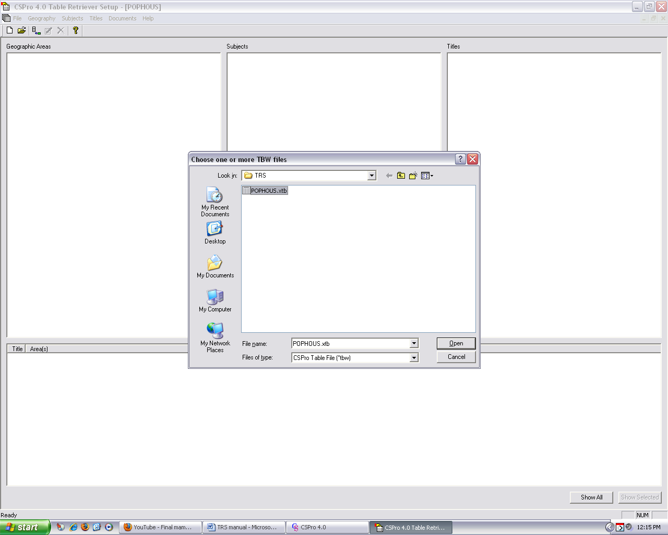

When the CSPro tables are successfully added to the TRS, they will appear under Titles. All geography levels found in the Area Names file will appear hierarchically under Geographic Areas i.e. Province, district etc. At the bottom of the window is a section that lists every table and a geographic area for which it is available. Figure 12 shows three tables added from the CSPro table file “POPHOUS,” namely Marital Status, Age by 5 year Groups and Relationship by Sex.

Figure 12. Tables Added

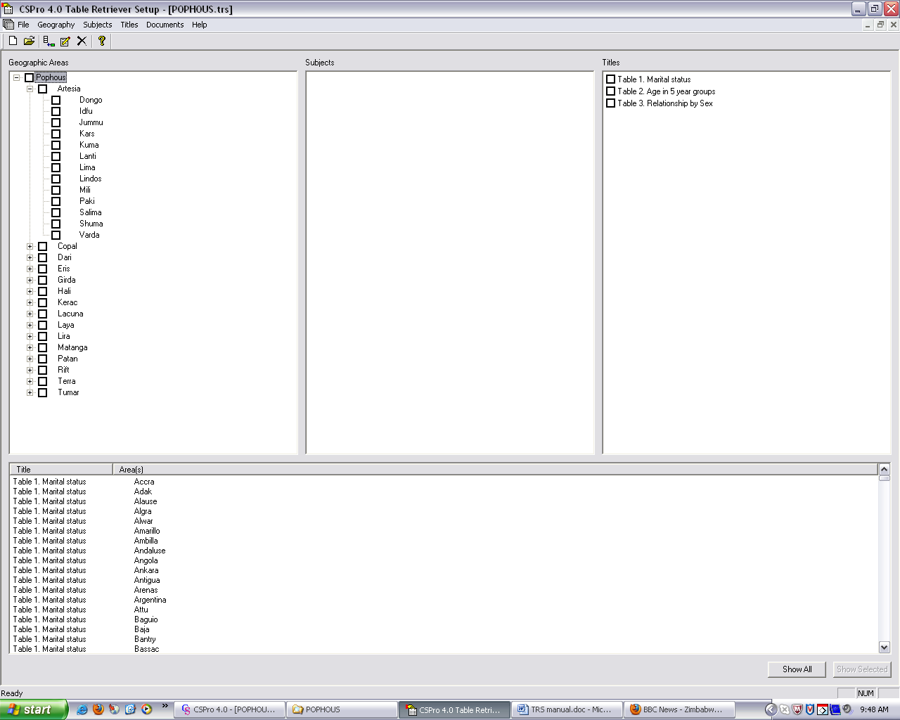

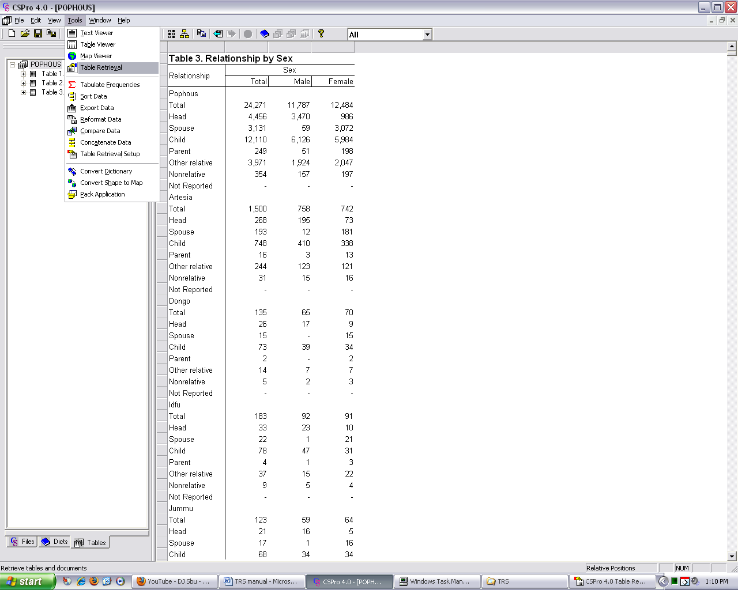

The user can then add a subject title under Subjects. This serves to group tables which are under a similar theme i.e. economics, fertility etc. The subject can be added by selecting ‘Add’ from TRS’s Subject menu. This will allow the user to then specify the subject name. In Figure 13 below, we group all three tables under the subject ‘Person Characteristics.’ The user can then add the three tables by selecting them all and dragging them to the subject ‘Person Characteristics’. The tables will then appear under that subject and a can be seen on a drop-down menu by clicking the “+” next to ‘Person Characteristics.’

In order to modify or delete a title or subject, the user can right-click the desired title and selecting the appropriate action from the resulting drop-down menu.

Figure 13. Adding Subjects to TRS
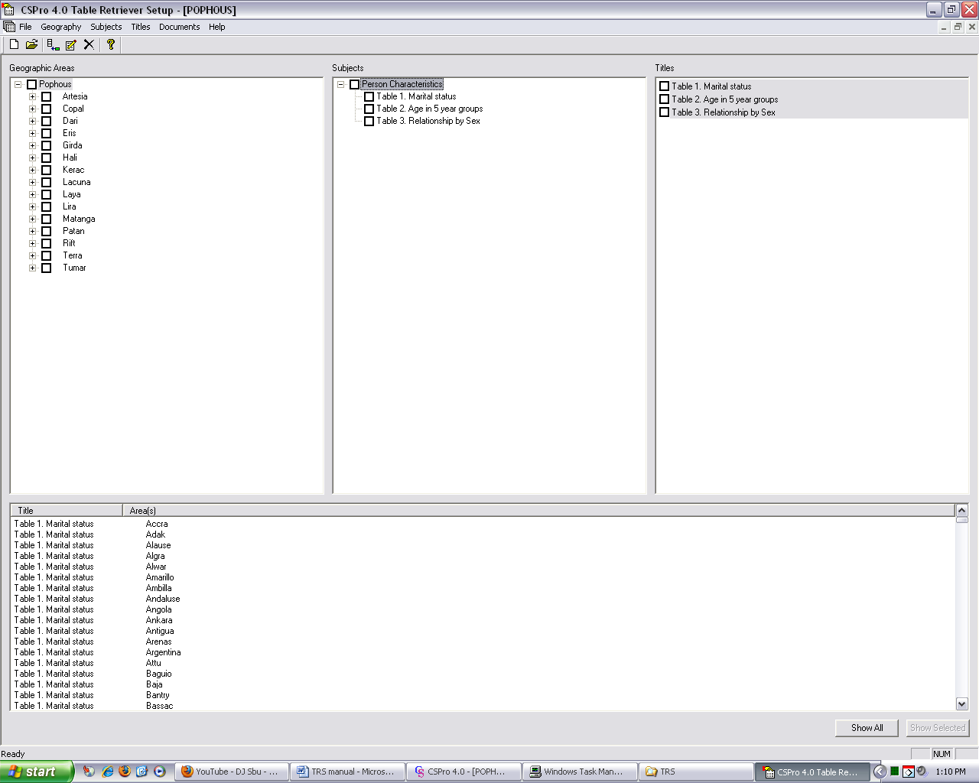

Table Retrieval

The Table Retrieval tool is used for viewing the tables added in the TRS. It allows users to select by geographic area, one or more of those tables. This tool can be opened by selecting Table Retrieval from CSPro’s Tools menu as shown in Figure 14 below.

Figure 14. Opening the Table Retrieval Tool
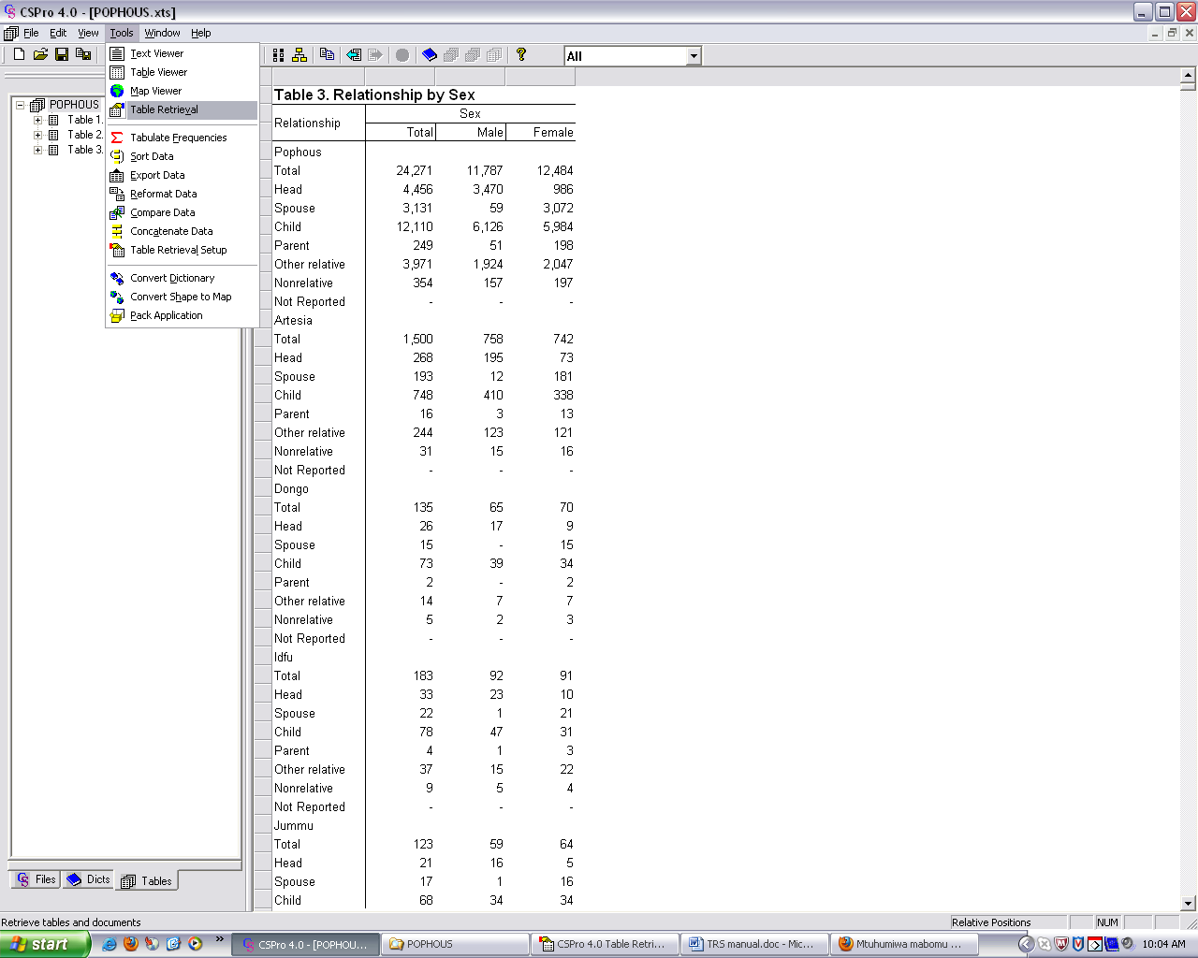

The user will then be prompted to enter the TRS that they wish to retrieve. In Figure 15 below, the TRS POPHOUS, which was created in previous steps, is selected.

Figure 15. Opening a TRS in Table Retrieval
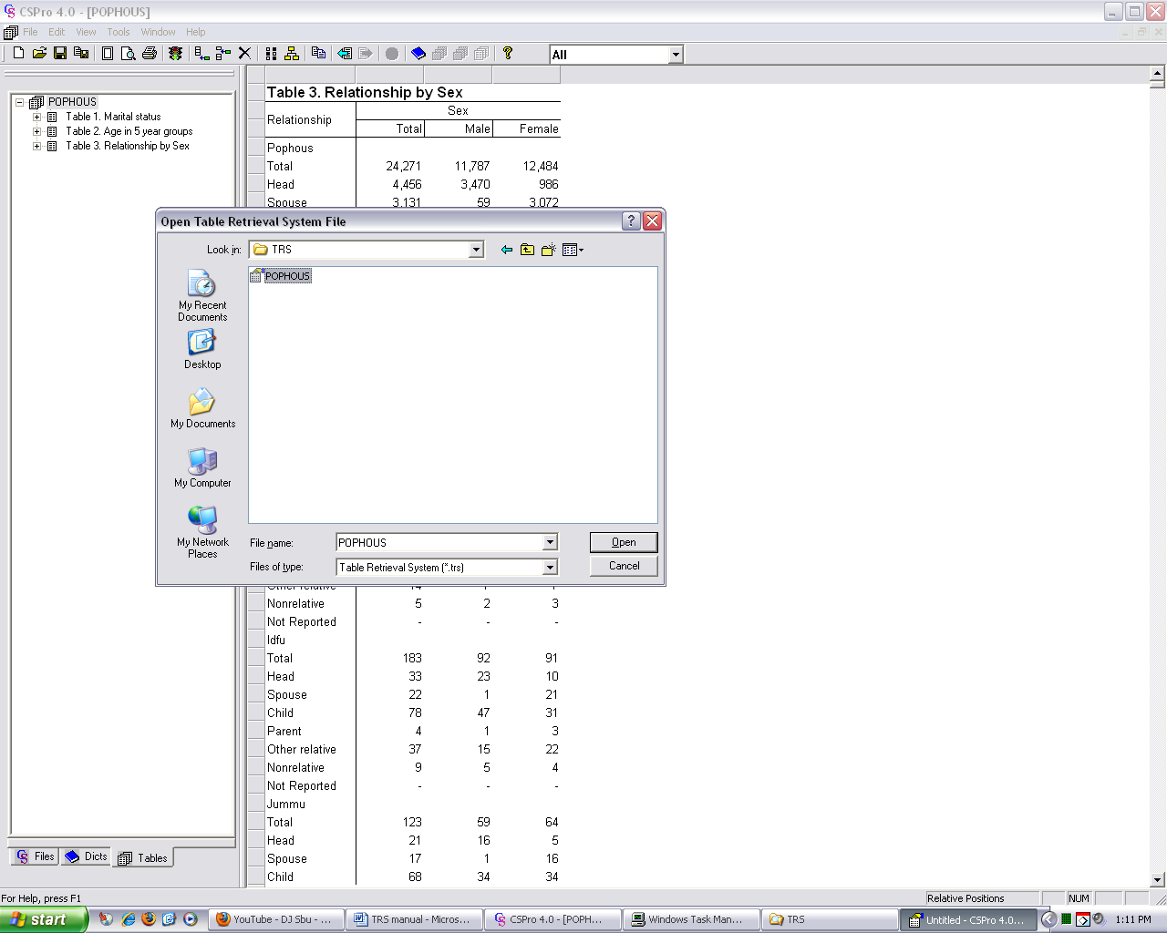

A new window, like the one in Figure 16 below, opens up once the TRS is selected. The tables that were added to the TRS will appear under the Subjects/Document Titles. A tree of tables associated with a particular subject can be expanded by clicking the plus sign next to the subject heading. In Figure 16 below, we see the tables ‘Marital Status,’ ‘Ages in 5 year groups’ and ‘Relationship by Sex’ after clicking the plus sign next to ‘Person Characteristics.’

The user can then select the tables and geographic areas for which they wish to retrieve the selected tables. The selection is done by clicking the box next to the geographic area, subject or document title. In order to retrieve the tables, the user can click the ‘run’ button (with the red and green light). The Table Retrieval tool will then notify the user of the number of tables that meet the selection and then prompt the user to go ahead with the retrieval (click OK), cancel or see details of the tables being retrieved.

Figure 16. Selecting Tables and Geographic Areas
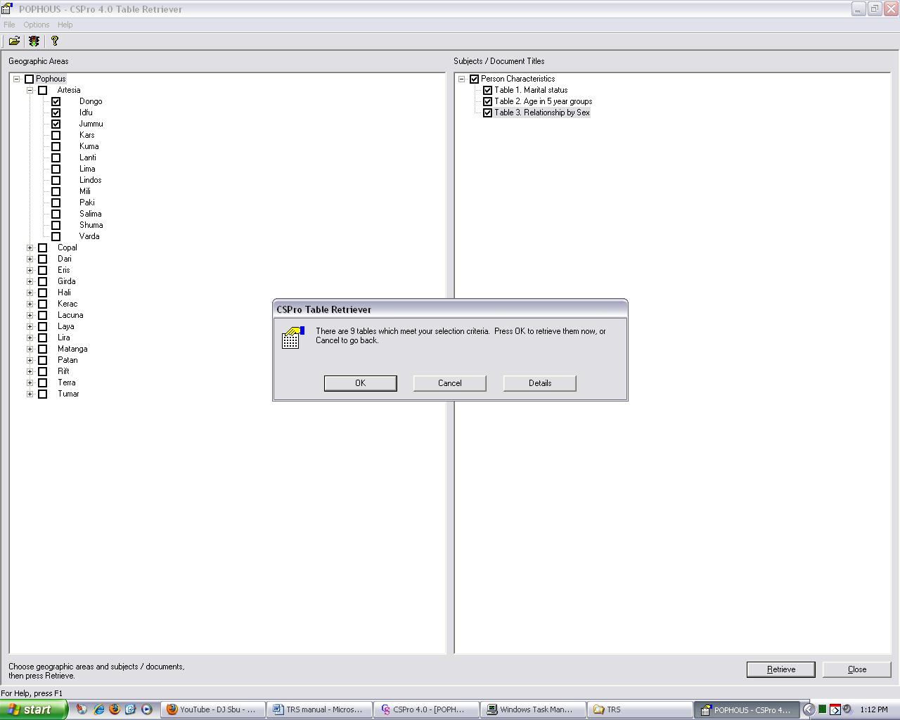

Once the table have been retrieved, CSPro automatically opens them using Table Viewer. On the left hand side of the Table Viewer there is a list of all the tables selected in the Table Retrieval tool in previous steps. The user can view a table by simply clicking on it. Figure 17 below shows the Marital Status table at the largest geographical unit Pophous.

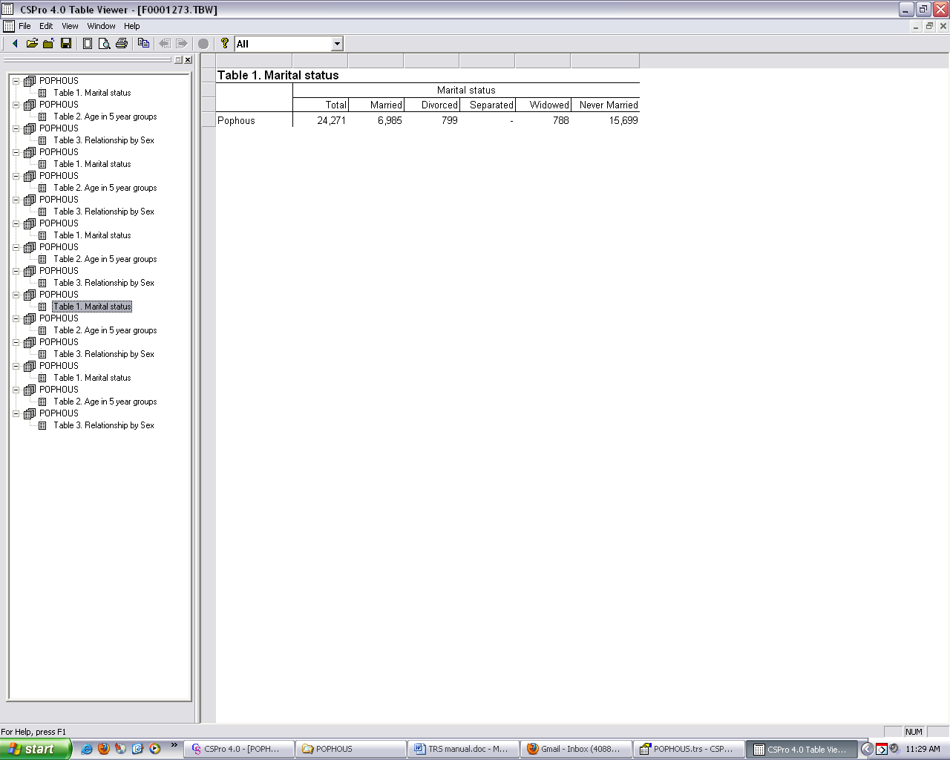
Figure 17. Viewing Retrieved Tables

Maps.
Once the TRS is created, one can also create maps for the different geographic areas specified in the area names file. Maps allow users to observe spatial/geographic distributions of the different variables available in the CSPro dictionary. For a detailed explanation on how to create maps refer to the Map Viewer manual. Below are maps for the variables for which we created tables in earlier steps, namely Marital Status, Age and Sex.

Figure 18. Maps of Pophous by province and district showing population aged 0 – 4 yrs
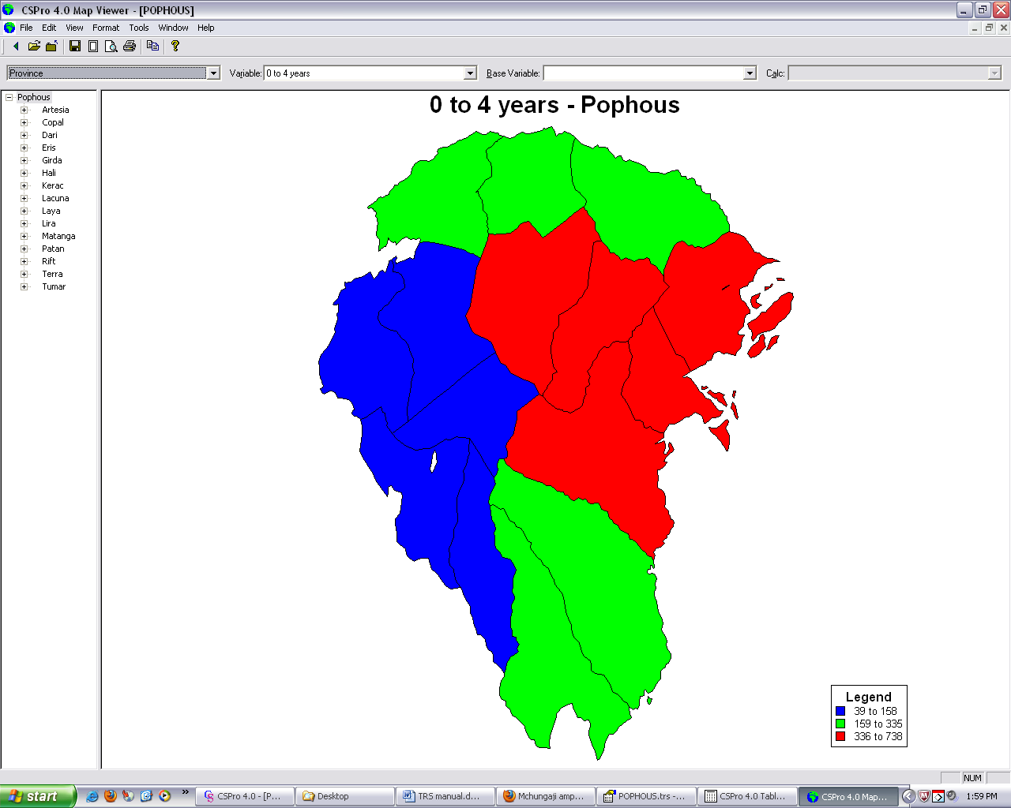
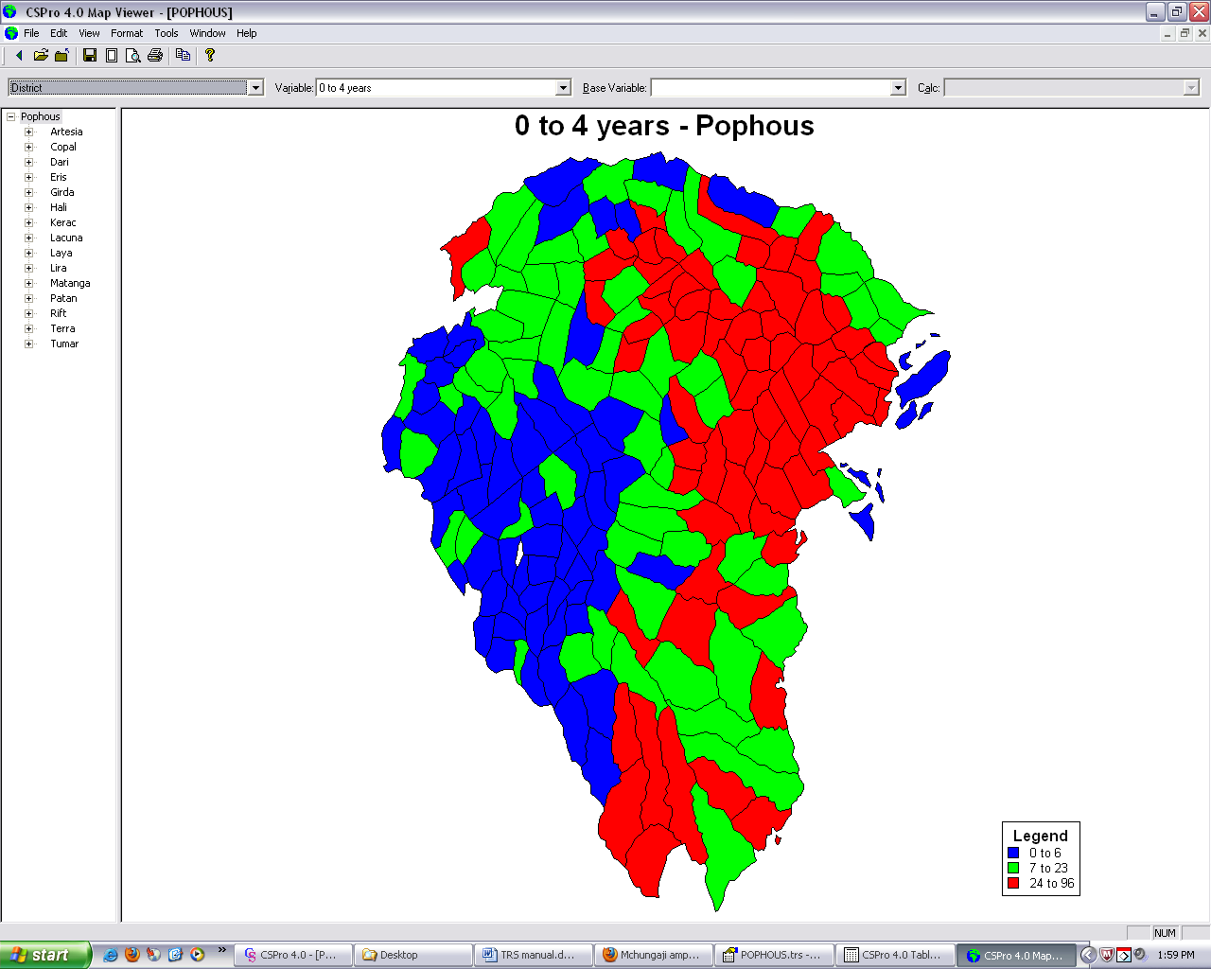

Figure 19. Maps of Pophous by province and district showing Marital Status
(married and never married)
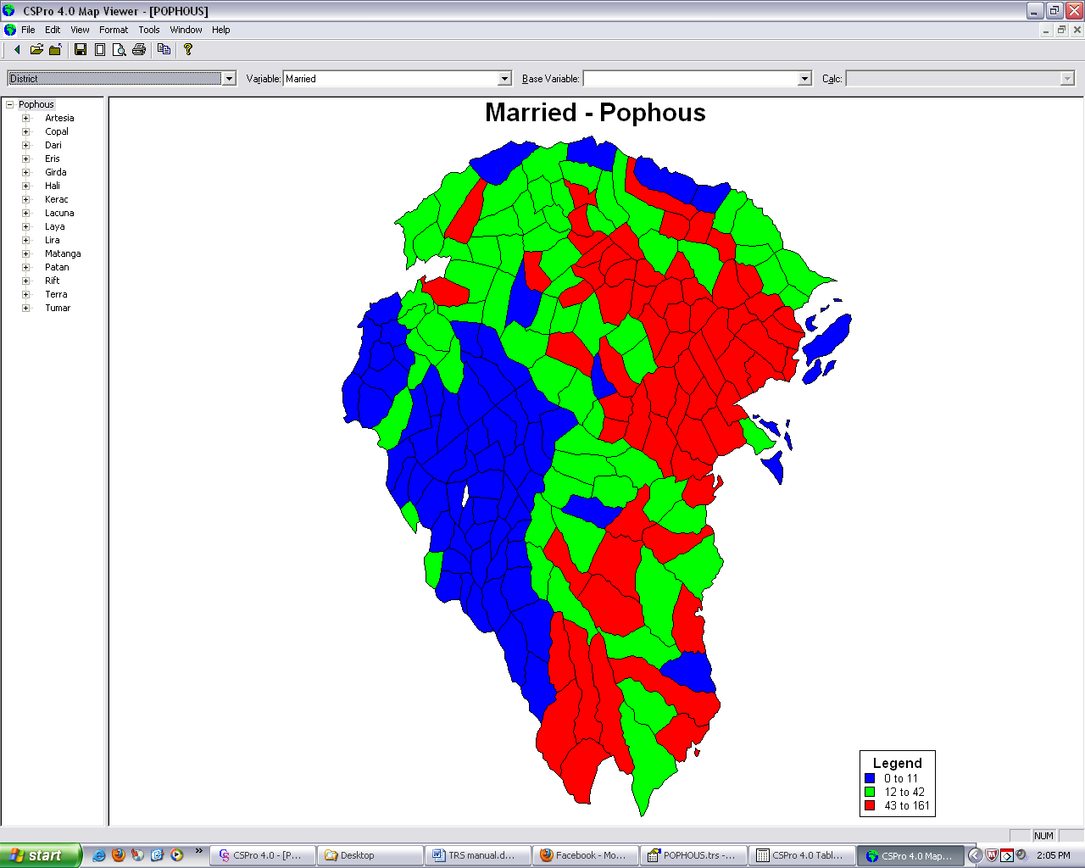
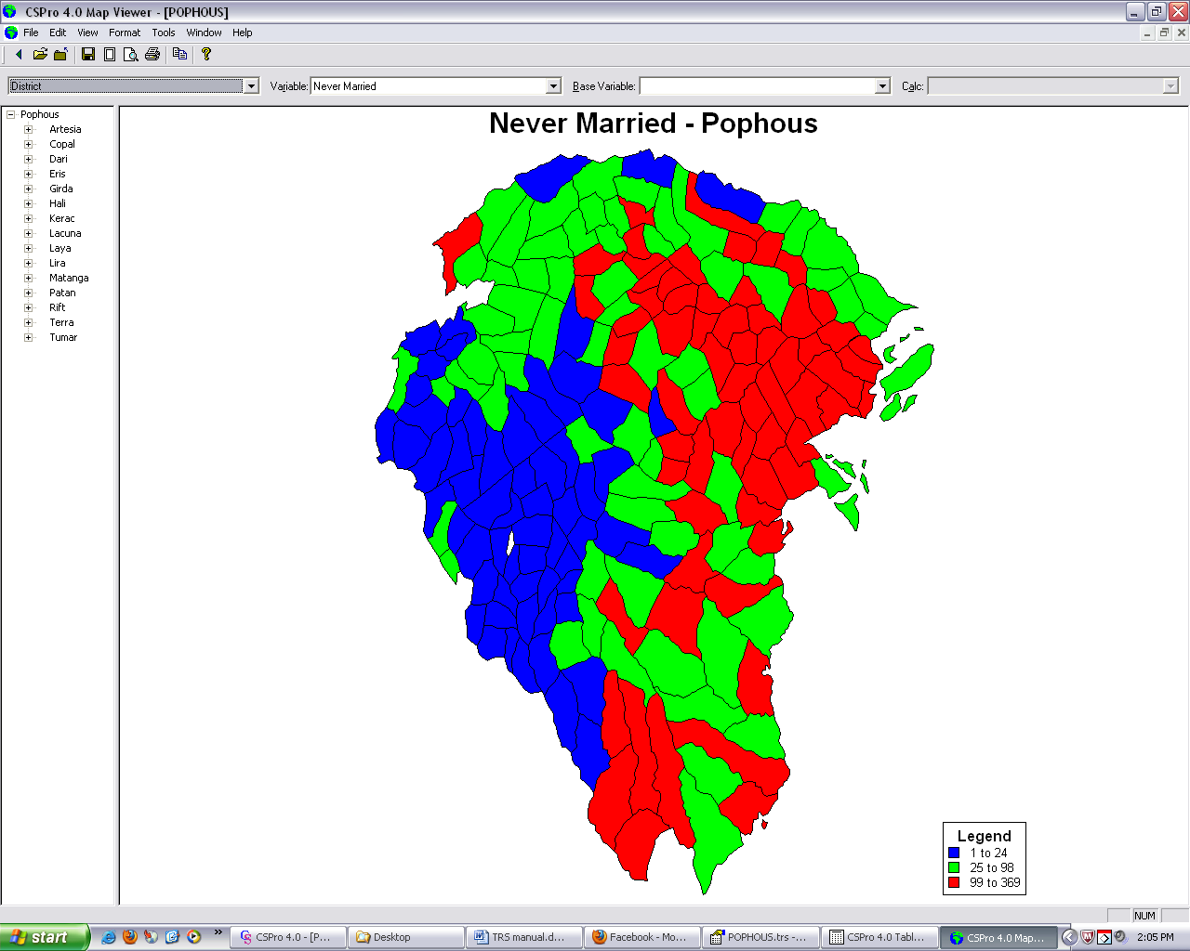

Figure 20. Maps of Pophous by district showing population by sex,
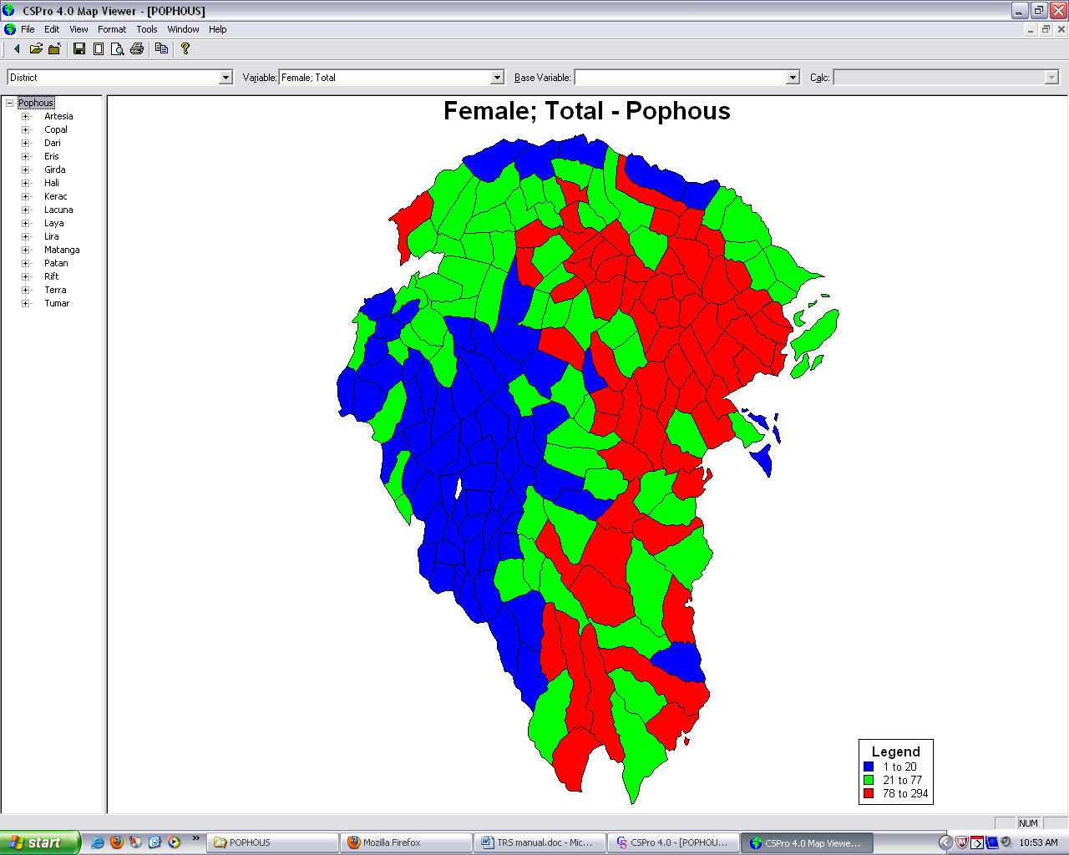
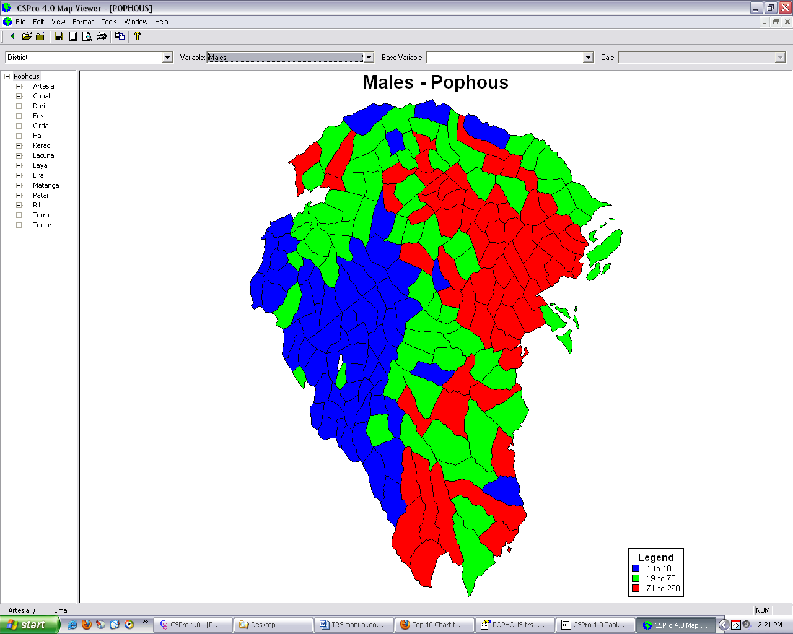

Pyramids.
TRS also allows users to add documents other than tables. These can be maps (as seen above), text files for documentation, graphs etc. This section will demonstrate addition of population pyramids, which are a form of graphs. Pyramids (or any other graphs) can be created using applications such as stata, Microsoft Excel etc. In the next example, the U.S Census Bureau’s Population Analysis System (PAS) package is used-particularly the Pyr2.xls worksheet-to create pyramids of Native and Foreign born population. The excel worksheet allows users to input population data for foreign and native born persons by age and sex for a particular geographic region. This input data can be obtained by creating appropriate CSPro tables. In this example tables of Place of birth (Native and foreign) by age and sex were created for different geographic areas in Pophous. The pyramids are then automatically created by using data from these tables as input in the Pyr2.xls worksheet. Below are examples of these superimposed pyramids for three different geographic regions in Pophous.

Figure 21. Native and Foreign Born: Artesia 2010
Population by age and sex
Population

Figure 22. Native and Foreign Born: Copal 2010
Population by age and sex
Population

Figure 23. Native and Foreign Born: Eris 2010
Population by age and sex
Population

The user can then save the pyramids individually as excel files and then add them to the TRS by selecting the Add Single option in TRS’s Documents menu. TRS will then prompt the user to select the document to be added. Once selected, the use will then enter the name of the document and the geography with which it is associated. The figure below shows the naming and geography association step.

Figure 24. Document naming and geography association

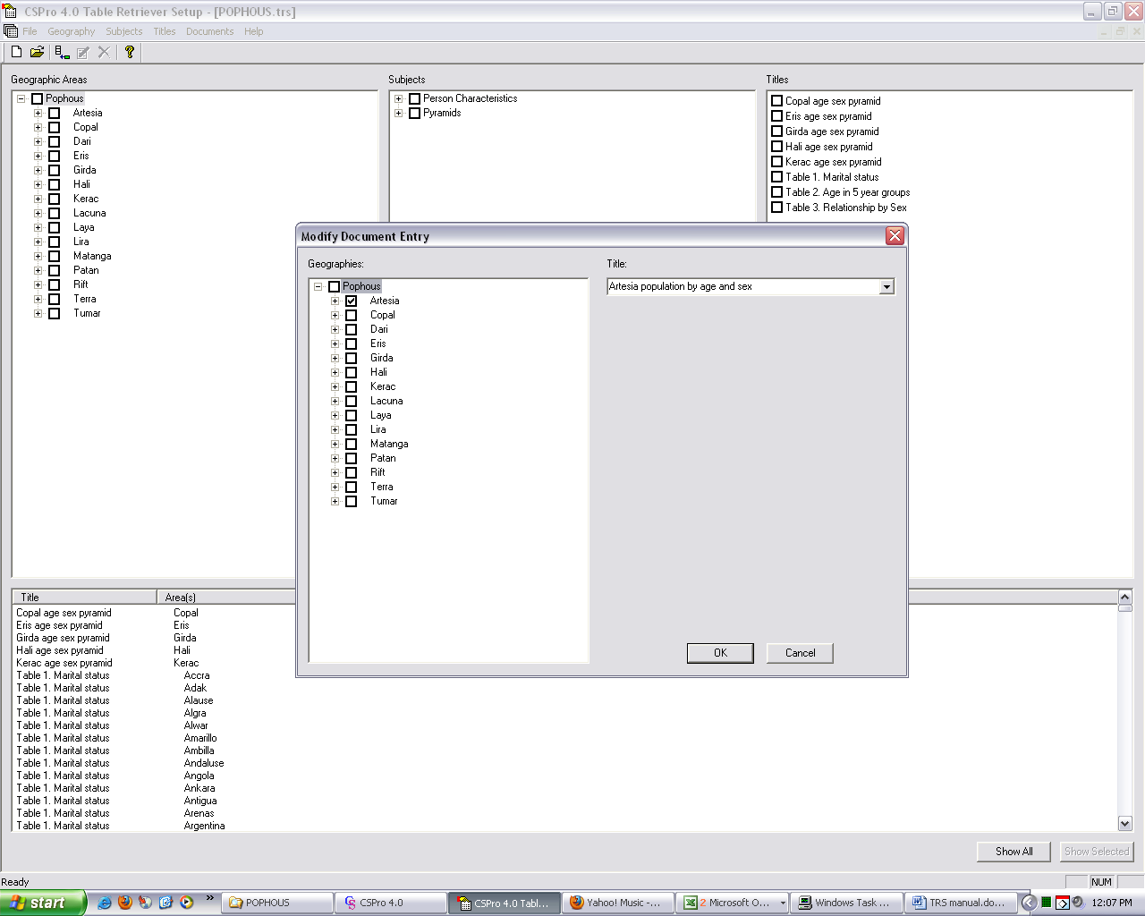

After adding the pyramids for desired geographic areas, the user can then drag the documents under appropriate subject title or create a new subject title for them. Once this is done, the documents – pyramids in this case – are ready for retrieval using the Table Retrieval tool as was the case for CSPro tables.

Dictionary
Like the pyramids and tables in previous sections of this document, the dictionary which contains the definition of the variables used to create the tables etc can also be included in the TRS. Addition of the dictionary is similar to that of the pyramids. Here the user selects ‘Add single document’ from TRS’s Documents menu and follows similar steps as those for pyramids. However, the file selected in this case is the dictionary saved as a .lst file. The user can then choose to associate the dictionary with all geographic areas. Below is a figure showing the naming and geography association stage of adding the dictionary.

Figure 25. Adding dictionary to the TRS.
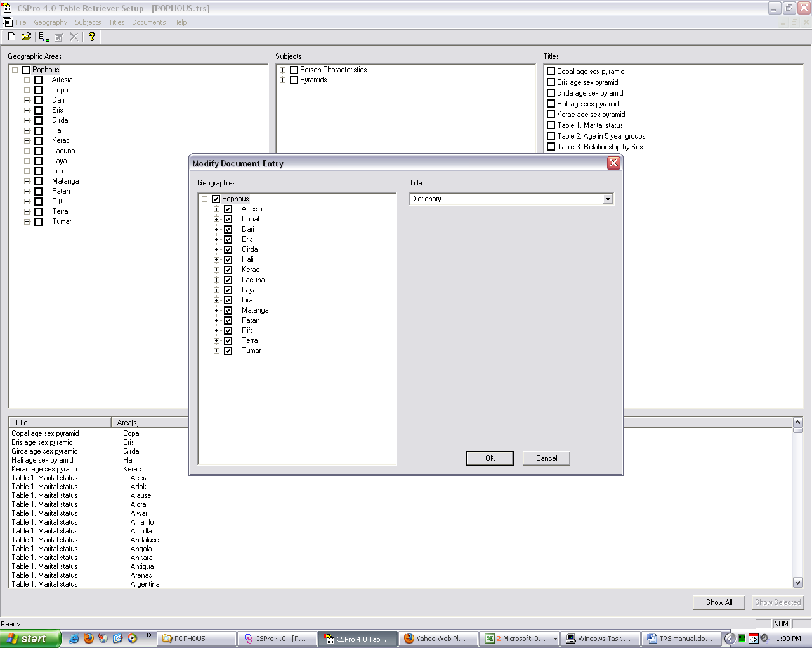

Below is a figure showing part of the dictionary with definition of some of the variables.

Figure 26. Dictionary with variable definition and notes.
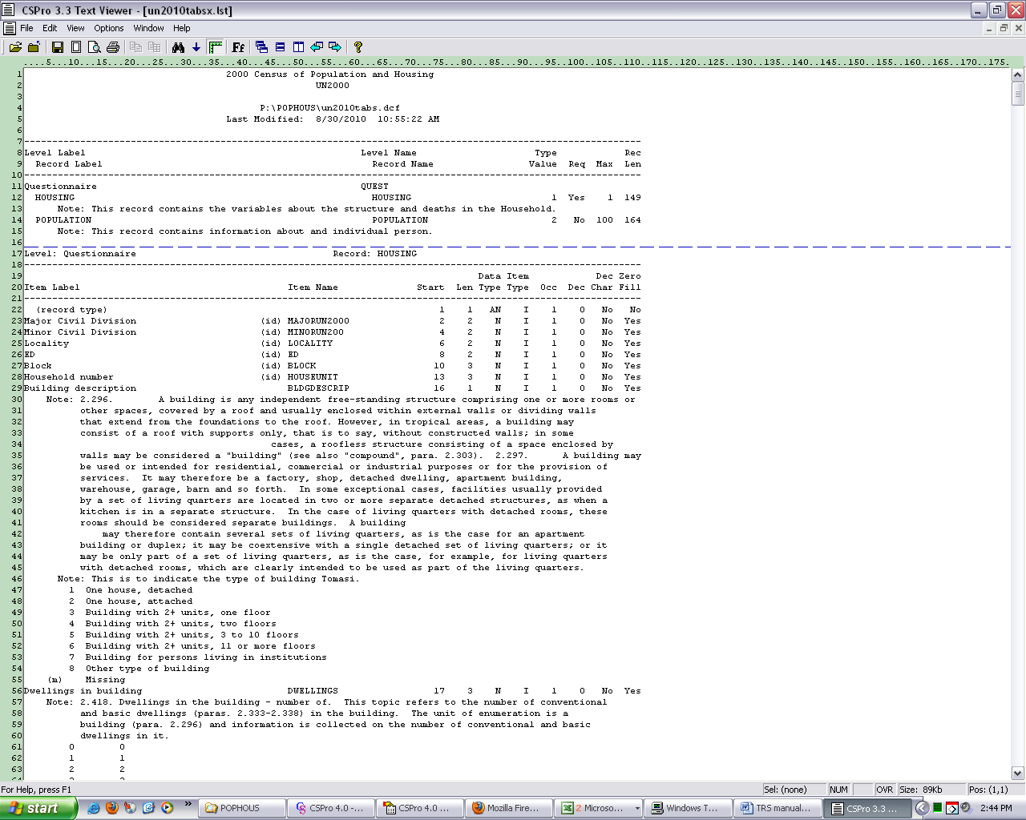

Use of Map Viewer in CSPro on POPHOUS data in this series.

